Classification of Moscow Metro station
- Introduction
Moscow Metro system is one of the largest public transit systems in the world. Moscow Metro system contains 264 stations. According to one survey more than 6 million people use this system daily. Basically, in this project we will classify Moscow Metro station based on their uses. For this I will use List of Moscow Metro Station data on Wikipedia.
- Business Problem
Our objective here is to classify metro station based on their uses. But in our data sets how station usage dose not show. So, for this problem we will use Foursquare data. Based on neighborhood and location data we will figure out what kind of people use nearest station.
By analysing this data, we can classify stations by their primary usage. This data can be useful for city planners to determine where from and where to people are most likely to travel for work and leisure, plan further extension of the network and find places for new development.
- Data
For this I will scrap below Wikipedia page by python.
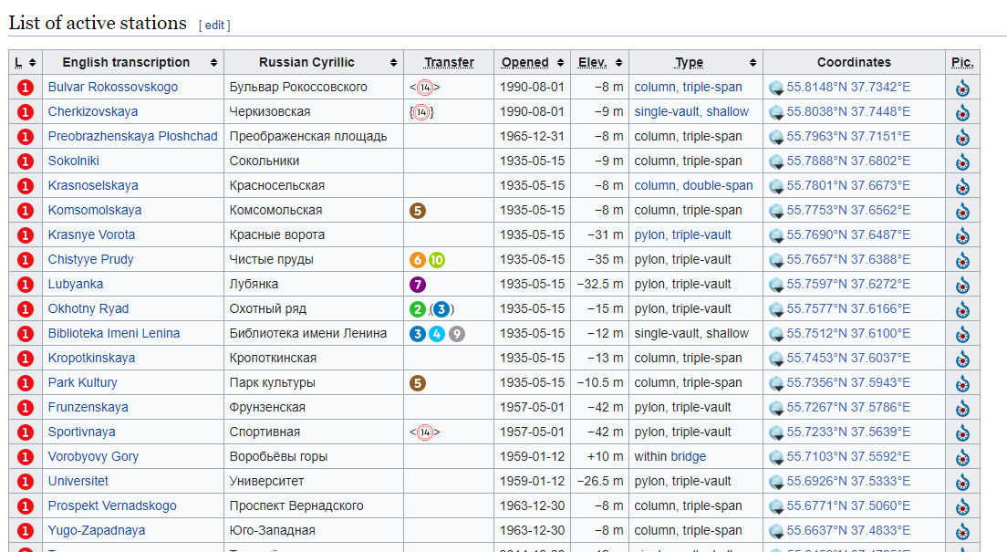
In this data sets column contains station name in English and Russian name of the stations, station birth year, type of the station and coordinates of the data.

